Correctional Education Council – Special Virtual Meeting

December 19, 2023
9:30 a.m. – 10 a.m.

Meeting link
meet.google.com/uqh-pnkb-ema
Join by phone
(US) +1 402-781-0465
PIN: 565087892

Council Meeting Agenda

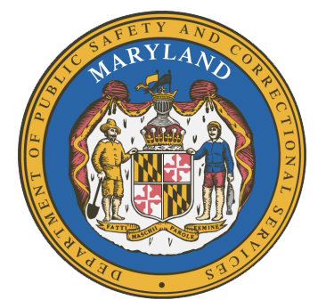
Welcome and Review of Annual Report ………………

Approval of Annual Report………………………………

Concluding Remarks……………………………………
Secretary Carolyn J. Scruggs & Deputy Secretary Jason Perkins-Cohen

ALL

Secretary Carolyn J. Scruggs & Deputy Secretary Jason Perkins-Cohen

