DIVISION OF OCCUPATIONAL & PROFESSIONAL LICENSING
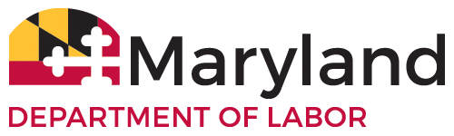
State Board of Cosmetologists and Barbers
1100 N. Eutaw St Room 121
Baltimore, MD 21201

Maryland State Board of Cosmetologists
December 5, 2022
5th Floor Conference Room/ Teleconference 10:00 AM
To access the meeting using video conferencing go to meet.google.com/hfy-umgk-iyo
To access the meeting by dialing in from a phone: (US) +1 541-714-5017 PIN: 490 463 886#
Board Meeting Agenda
- Quorum Announced.
- Meeting Called to Order- Chairperson 10:00
- Approval of Agenda
- Approval of November 7, 2022 Minutes
- New Business
- Apprentice Restart-THI QUYNH NHU LAM
- Apprentice Restart- ANNIE NGUYEN
- Old Business
- Staffing Update

- Distance Learning

- Legislative Updates
- Curriculum Approval
- Inspection Report-
- Public Comment-
- Adjournment
- ****A portion of this meeting may be closed pursuant to the General Provisions Article Annotated Code of Maryland, §3-305(b)

